

A PROJECT REPORT ON

**“WEBSITE ON FOOD ORDER SYSTEM”**

SUBMITTED TO,

SHIVAJI UNIVERSITY, KOLHAPUR

FOR THE PARTIAL FULFILLMENT OF

**BACHELOR OF COMPUTER APPLICATON BCA III (SEM V)**

SUBMITTED BY,

**Lohar Priyanka Santosh**

**Sawant Pooja Laxman**

**Shinde Nikhil Shashikant**

**Shinde Rohan Shivaji**

UNDER THE GUIDENCE OF

**Mr. V. D. Chavan**

THROUGH

THE DIRECTOR,

**RAYAT SHIKSHAN SANSTHA’S**

**KARMAVEER BHAURAO PATIL INSTITUTE OF**

**MANAGEMENT STUDIES AND RESEARCH,**

**VARYE, SATARA**



**RAYAT SHIKSHAN SANSTHA’S**

**KARMAVEER BHAURAO PATIL INSTITUTE OF MANAGEMENT STUDIES AND RESEARCH, VARYE, SATARA**

**INSTITUTE RECOMMENDATION**

This is to certify that**, Miss. Lohar Priyanka Santosh, Miss Sawant Pooja Laxman, Mr. Shinde Nikhil Shashikant, Mr. Shinde Rohan Shivaji** is the bonafied student of this institute studying in BCA III (semester-v) have completed the project report entitled **“WEBSITE ON FOOD ORDER SYSTEM”** for the partial fulfilment of the requirement of the degree “BACHELOR OF COMPUTER APPLICATON” (SEMESTER-V) program for the academic year 2021-2022.

To the best of my knowledge and belief, the original work and not submitted earlier anywhere for any purpose.

**Date: Dr. B. S. Sawant**

**Place: (Director)**



**RAYAT SHIKSHAN SANSTHA’S**

**KARMAVEER BHAURAO PATIL INSTITUTE OF MANAGEMENT STUDIES AND RESEARCH, VARYE, SATARA**

**CERTIFICATE**

This is to certify that**,** Project represent titled **“Website on Food Order System”** submitted by **Miss. Lohar Priyanka Santosh** for the partial fulfilment of the requirement of the degree “BACHELOR OF COMPUTER APPLICATON” (SEMESTER-V) program for the academic year 2021-2022. To the best of my knowledge and belief, the original work and not submitted earlier anywhere for any purpose.

**Place: Satara**

**Date:**

**Mr. V. D. Chavan Dr. R. D. Kumbhar**

**(Project guide) External Examiner (H.O.D)**



**RAYAT SHIKSHAN SANSTHA’S**

**KARMAVEER BHAURAO PATIL INSTITUTE OF MANAGEMENT STUDIES AND RESEARCH, VARYE, SATARA**

**CERTIFICATE**

This is to certify that**,** Project represent titled **“Website on Food Order System”** submitted by **Miss. Sawant Pooja Laxman** for the partial fulfilment of the requirement of the degree “BACHELOR OF COMPUTER APPLICATON” (SEMESTER-V) program for the academic year 2021-2022. To the best of my knowledge and belief, the original work and not submitted earlier anywhere for any purpose.

**Place: Satara**

**Date:**

**Mr. V. D. Chavan Dr. R. D. Kumbhar**

**(Project guide) External Examiner (H.O.D)**



**RAYAT SHIKSHAN SANSTHA’S**

**KARMAVEER BHAURAO PATIL INSTITUTE OF MANAGEMENT STUDIES AND RESEARCH, VARYE, SATARA**

**CERTIFICATE**

This is to certify that**,** Project represent titled **“Website on Food Order System”** submitted by **Mr. Shinde Nikhil Shashikant** for the partial fulfilment of the requirement of the degree “BACHELOR OF COMPUTER APPLICATON” (SEMESTER-V) program for the academic year 2021-2022. To the best of my knowledge and belief, the original work and not submitted earlier anywhere for any purpose.

**Place: Satara**

**Date:**

**Mr. V. D. Chavan Dr. R. D. Kumbhar**

**(Project guide) External Examiner (H.O.D)**



**RAYAT SHIKSHAN SANSTHA’S**

**KARMAVEER BHAURAO PATIL INSTITUTE OF MANAGEMENT STUDIES AND RESEARCH, VARYE, SATARA**

**CERTIFICATE**

This is to certify that**,** Project represent titled **“Website on Food Order System”** submitted by **Mr. Shinde Rohan Shivaji** for the partial fulfilment of the requirement of the degree “BACHELOR OF COMPUTER APPLICATON” (SEMESTER-V) program for the academic year 2021-2022. To the best of my knowledge and belief, the original work and not submitted earlier anywhere for any purpose.

**Place: Satara**

**Date:**

**Mr. V. D. Chavan Dr. R. D. Kumbhar**

**(Project guide) External Examiner (H.O.D)**

**DECLARATION**

TO,

THE DIRECTOR

KARMAVEER BHAURAO PATIL

INSTITUTE OF MANAGEMENT STUDIES AND RESEARCH

VARYE, SATARA

Respected sir,

We undersigned here by declared that the project report title “**Website on Food Order System**” has developed under the guidance of Mr. V. D. Chavan and submitted to Shivaji university Kolhapur for the partial fulfilment of the requirement of the degree “BACHELOR OF COMPUTER APPLICATION” (semester –V) which is written and submitted by us is our original work.

The content of this project report we have not copied from any source. we understand that any coping is able to punish in a way that university authorities deem fit.

**Place: Satara**

**Date:**

**Yours Sincerely,**

**Lohar Priyanka Santosh**

**Sawant Pooja Laxman**

**Shinde Nikhil Shashikant**

**Shinde Rohan Shivaji**

**ACKNOLEDGEMENT**

We take this opportunity to thanks all those who has directly inspired, director and helped us towards successfully completion of this project report. We are grateful to our team of their highly encouraging and co-operative attitude.

We express our sincere thanks to director Dr. B.S. Sawant, KBPIMSR, Satara. for their encouragement throughout the project report. We are thankful to our project guide Mr. Chavan V.D. for this valuable guidance. we express our sense of gratitude towards our friends and parents for their constant moral during our project report.

**Place: Satara**

**Date:**

**Yours sincerely,**

**Lohar Priyanka Santosh**

**Sawant Pooja Laxman**

**Shinde Nikhil Shashikant**

**Shinde Rohan Shivaji**

**INDEX**

|  |  |  |
| --- | --- | --- |
| **CHAPTER** | **PARTICULAR** | **PAGE NO.** |
| 1 | **Introduction to project**  A Introduction  B Existing system  C scope of system | 1-4 |
| 2 | **Proposed system**  A Objectives  B Requirement  C SRS (system requirement specification) | 5-8 |
| 3 | **System analysis**  A system diagrams  B DFD (data flow diagram)  C ERD (entry requirement diagram) | 9-12 |
| 4 | **System design**  A database designs  B input design  C output design  D Reports | 13-24 |
| 5 | **Problem statement**  A Advantages  B Disadvantages | 25-27 |
| 6 | **Conclusion and limitations**  A conclusion  B limitations  C future Scope | 28-29 |
| 7 | **Reference**  A web  B book | 30 |

**Chapter 1**

**INTRODUCTION TO SYSTEM**

Introduction

Existing system

Need and Scope of System

**INTRODUCTION**

The aim of developing Website on Food Ordering System is to replace the traditional way of taking orders with computerized system. Another important reason for developing this website is to prepare order summary reports quickly and correct format at any point of time when required.

This Website helps to do all functionalities more accurately and faster way. Food ordering System reduces manual works and improves efficiency of restaurant. This Website is helping Food Ordering to maintain the food stock and cash flows and there are many more functionalities like:

To store customers records.

Control orders and services.

Billings.

Control multiple branches.

The main goal is to maintain the functions in an effective and accurate manner and also it is reducing the use of manual entries. This website helps food orders to maintain day to day records in system. It is keeping a proper record of the database.

**EXISTING SYSTEM**

In the existing website are done only manually we have to computerize using this website.

. Lack of security of data.

. More man power.

. Time consuming.

. Consumes large volume of paperwork.

. Needs manual calculations.

. No direct role for the higher officials.

**SCOPE OF THE PROJECT**

The Scope of the website are as follows:

Food Ordering System can provide preferred quality, kitchen needs, essential restaurant supplies and more, through this online.

It may help collecting perfect management in details in a very short time, the collection will be obvious, simple and sensible. It also helps in current all works relative to Food Ordering System. It will be also reduced the cost of collecting the management & collection procedure will go on smoothly.

To assist the staff in capturing the effort spent on their respective working areas

It satisfies the user requirement

Be easy to understand by the user

Be easy to operate

Have a good user interface.

Be expandable

Delivered on schedule within the budget

**Chapter 2**

**Proposed system**

A Objectives

B Requirement

CSRS (system requirement specification)

**PROPOSED SYSTEM**

The aim of proposed system is to develop a system of improved facilities. The proposed system can overcome all the limitations of the existing system. The system provides proper security and reduces the manual work

This system is a bunch of benefits from various points of view. This online website enables the end-users to register to the system online, select the food items of their choice from the menu list, and order food online. Also, at the time of home delivery depending upon the customer’s choice and convenience. Now this same person will assign the orders to the specialist chef to be completed within a fixed duration of time. As soon as the chef prepares the food, the later person forwards the parcels to the delivery persons assigned with the location and customer identity of the customer along with the bill status.

Proper control of the higher officials

Minimize manual data entry

Minimum time needed for the various processing.

Greater efficiency

Better service

User friendliness and interactive

Minimum time required.

**OBJECTIVES**

The general objectives of the study are to develop a reliable, convenient and accurate Food Ordering website. The study has the following specific objectives:

* To develop a website that will surely satisfy the customer service.
* To design a website able to accommodate huge number of orders at a time.
* To evaluate its performance and acceptability in terms of security, user-friendliness, accuracy and reliability.
* Minimize the time of ordering.
* One of the main objectives of a website to ensure customer satisfaction. The proposed system, manipulation of orders to the customers be so easy and quick by just touching on the tablet and choosing the desired menu.
* To automatically compute the bill.
* The system will also automatically calculate and displays the final bill so the bills will ready to print without having any error because the information for that item is already inserted.

**SYSTEM REQUIREMENTS**

* The user should have the appropriate version of windows.
* The system should have up to 4 GB ram minimum requirement for the website.
* The website should be installed on the system.
* So, this is the overall process of making the Online food order websites worked, and the user can get the policy without any headache of the agent and sometimes do not need to provide a commission to them.

**USER REQUIREMENT:**

The system will be designed to be user friendly. The user friendly and interactive interfaces design helps to achieve this by enabling customers to easily browse through the menus, place orders with just a few clicks. The system shall validate the username and password in order to login and make changes to the system:

* Passwords should be encrypted
* Usability Requirement
* The system should have a simple and easy-to-learn graphic user interfaces

**SOFTWARE REQUIREMENT:**

* Operating system: - windows, Linux, mac OS
* Programming language: - Html, CSS, Java

**Chapter 3**

**System Analysis:**

**A DFD (Data flow diagram)**

**B ERD (Entity Requirement Diagram)**

**DFD (Data flow diagram)**

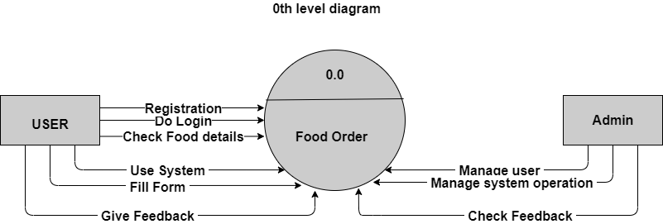

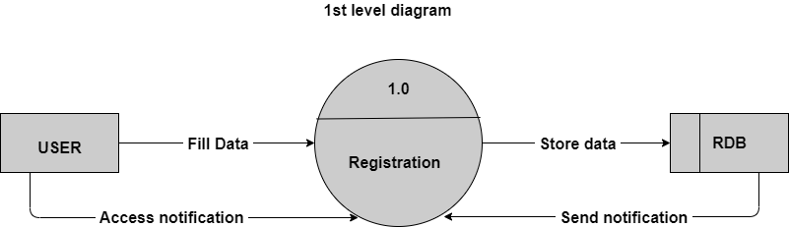

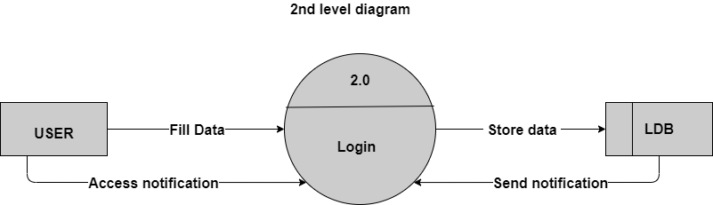

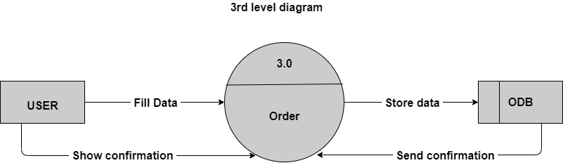

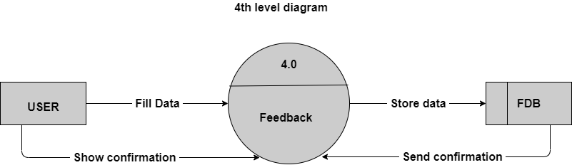

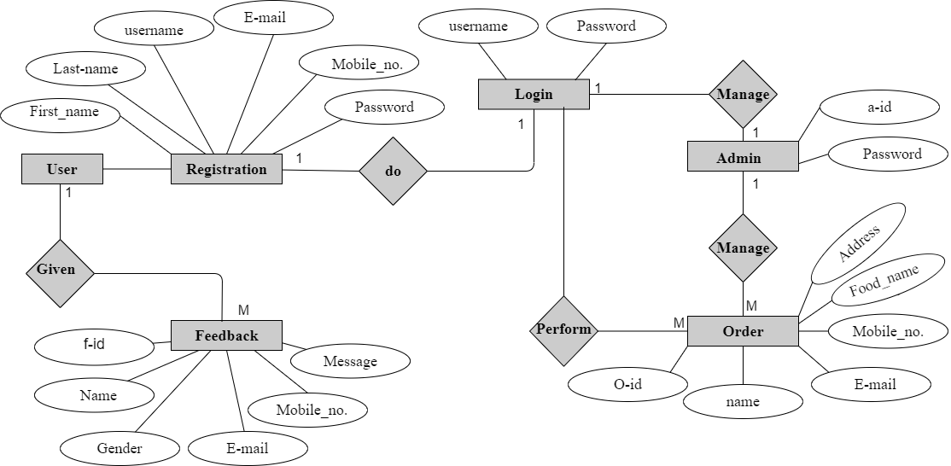**ERD (Entity Requirement Diagram):**

**Chapter 4**

**System Design:**

* + - 1. **Input Design**
      2. **Output Design**
      3. **Database Design**
      4. **Reports**

Registration page:

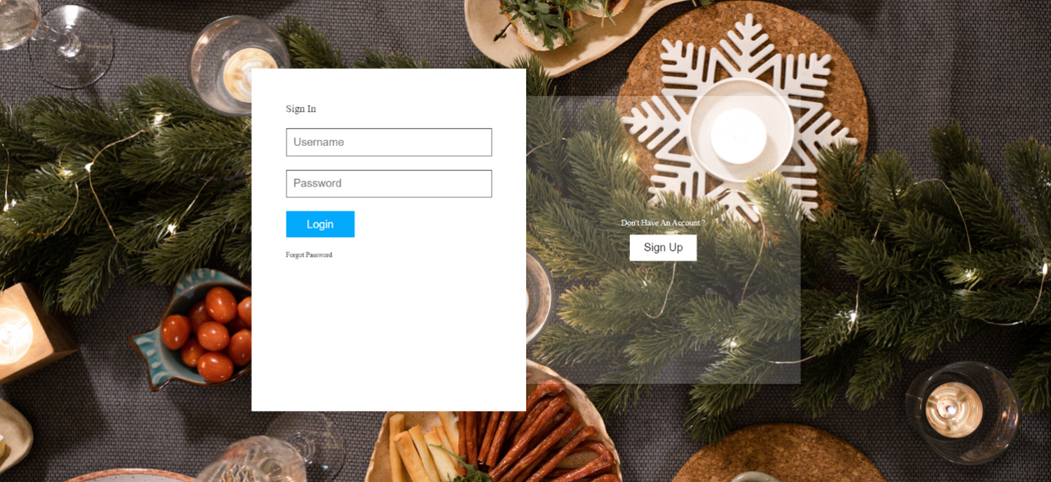

Login page:

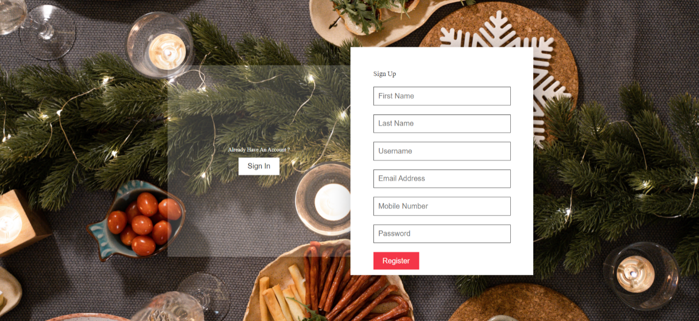

Home page:

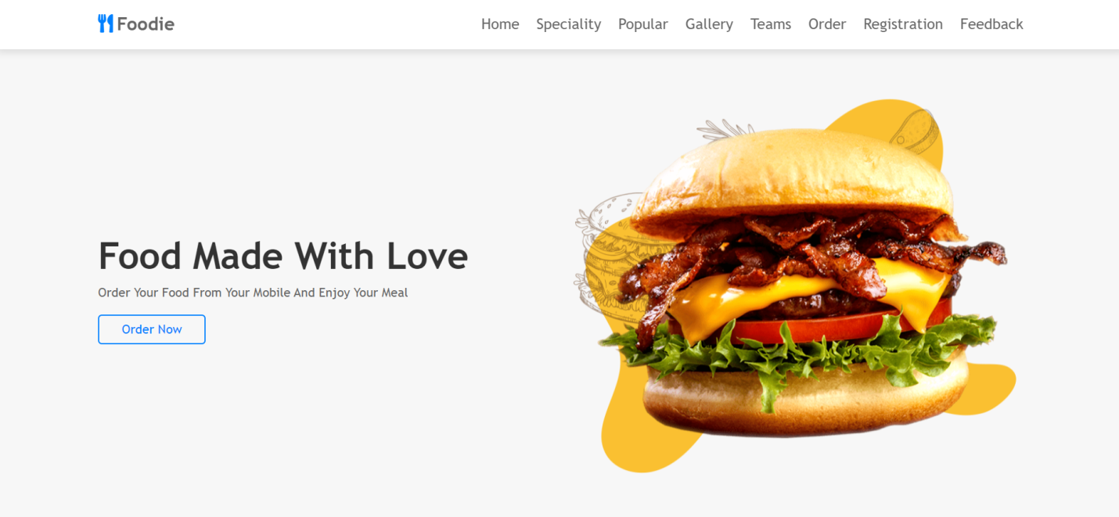



Specialty section:



Specialty Section:

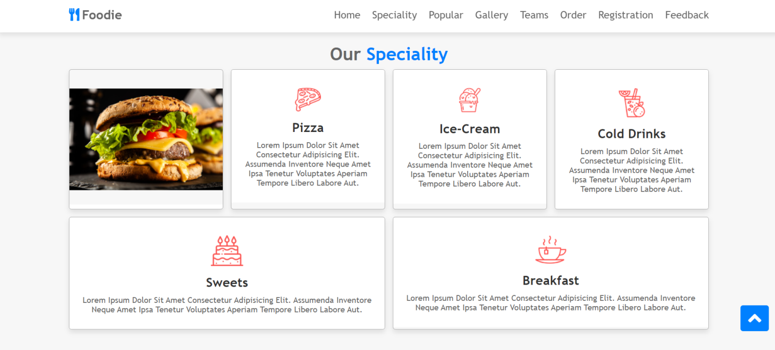



Popular Section:

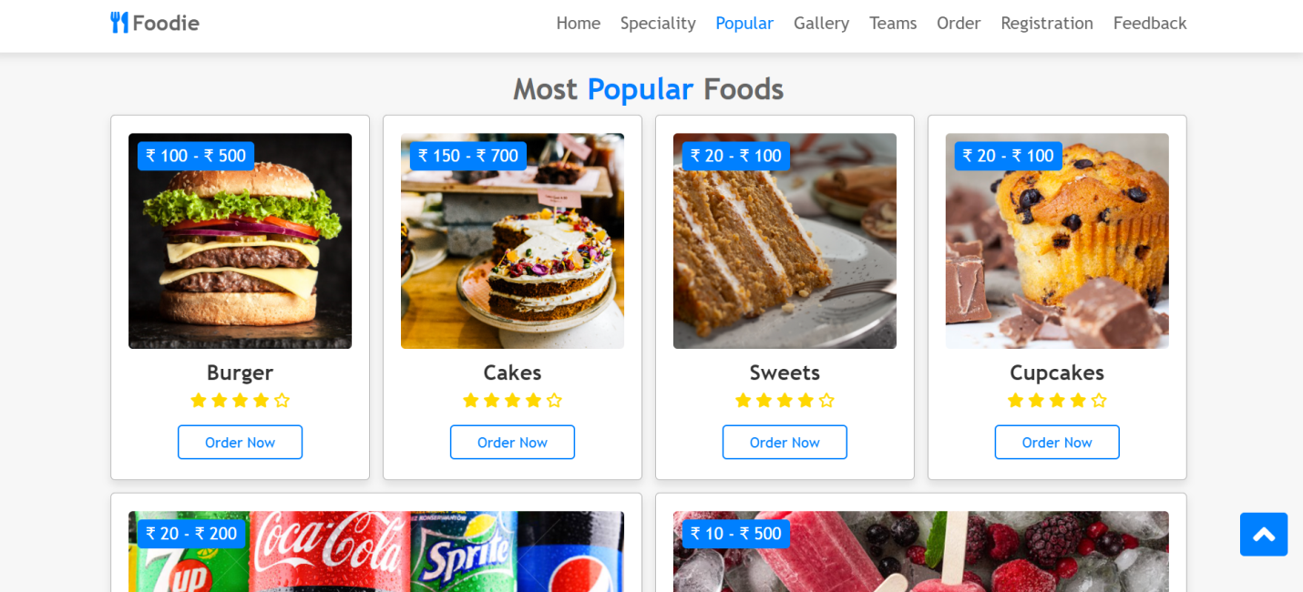

Working Process:



Gallery Section:

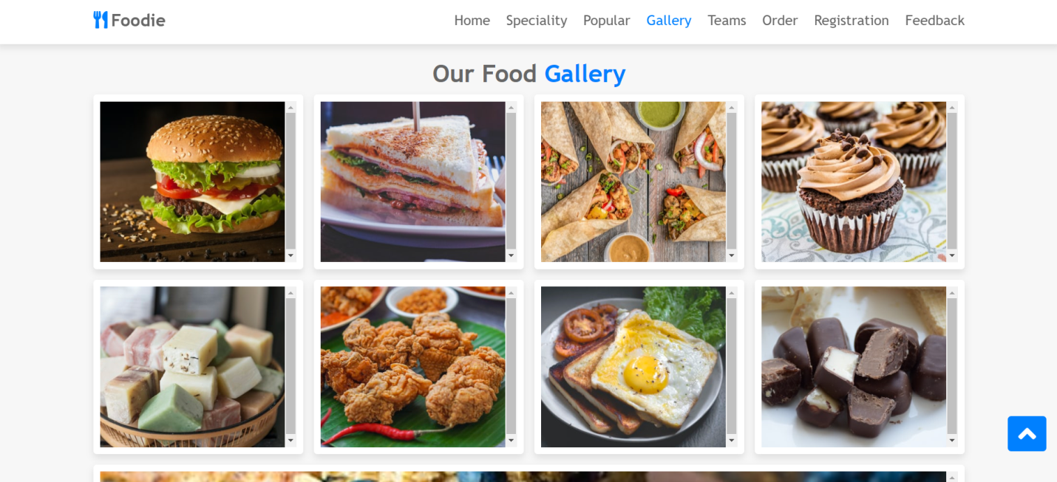

Our Teams:

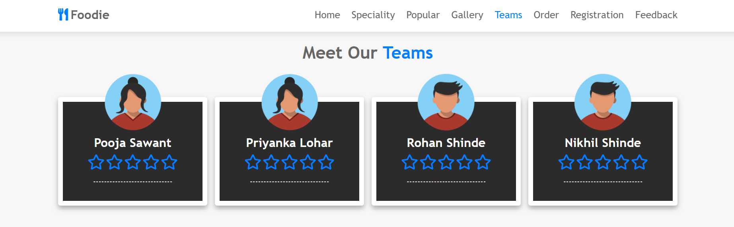

Order Section:

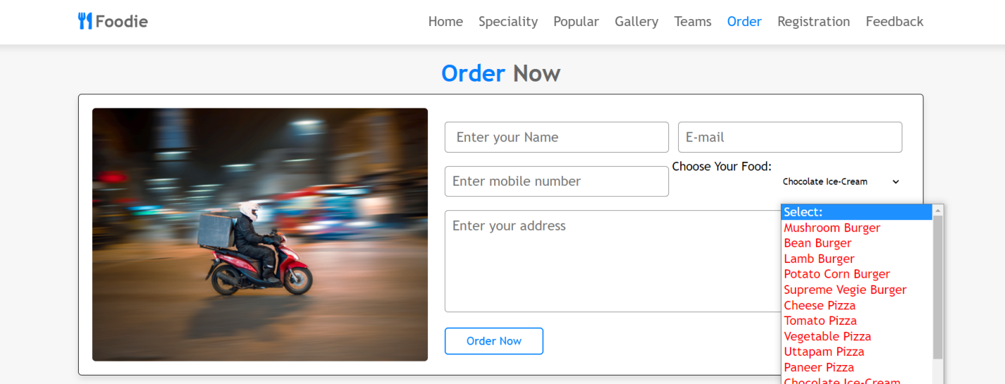

Feedback Form:

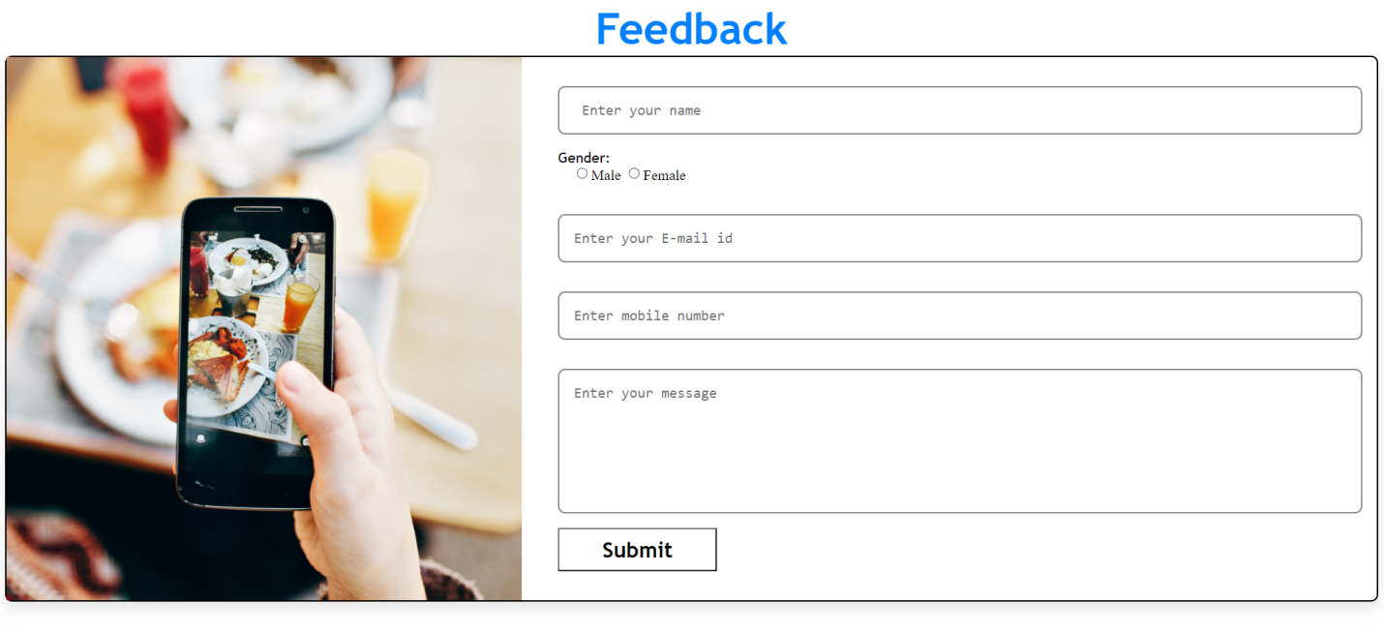

**DATABASE DESIGN**

|  |  |  |  |
| --- | --- | --- | --- |
| **Field Name** | **Data Type** | **Description** | **Key** |
| Registration_id | int | Registration id | - |
| First_name | Text | First name | - |
| Last_name | Text | Last name | - |
| Username | Varchar | Username | - |
| Email | Varchar | Email address | - |
| Mobile_no | Bigint | Mobile no | - |
| Password | Varchar | Password | - |

**Registration:**

**Login:**

|  |  |  |  |
| --- | --- | --- | --- |
| **Field Name** | **Data Type** | **Description** | **Key** |
| Username | Varchar | Username | - |
| password | Varchar | Password | - |

**Order:**

|  |  |  |  |
| --- | --- | --- | --- |
| **Field Name** | **Data Type** | **Description** | **Key** |
| Order_id | Int | Order id | - |
| Name | Text | Full name | - |
| Email | Varchar | Email address | - |
| Mobile_no | Bigint | Mobile number | - |
| Food_name | Varchar | Food name | - |
| Address | Varchar | Your address | - |

**Feedback:**

|  |  |  |  |
| --- | --- | --- | --- |
| **Field Name** | **Data Type** | **Description** | **Key** |
| feedback_id | Int | Feedback id | - |
| name | Text | Your full name | - |
| gender | Text | Gender | - |
| email | Varchar | Email address | - |
| number | Bigint | Mobile no | - |
| message | Text | Text Message | - |

**REPORTS**

**Report of Registration:**

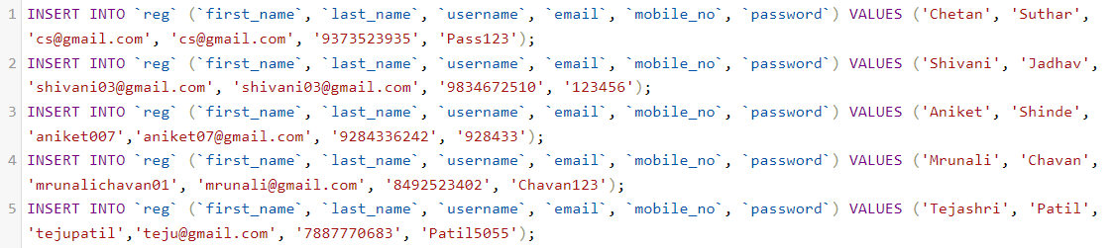

|  |
| --- |
| **Report of Registration:** |

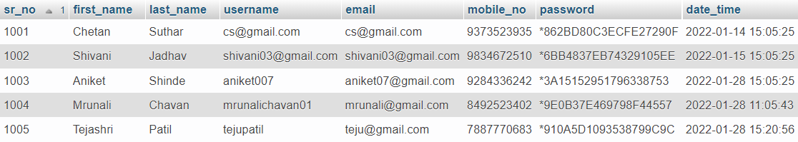

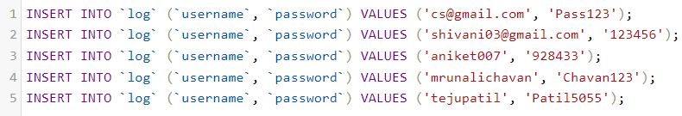

|  |
| --- |
| **Report of Login:** |

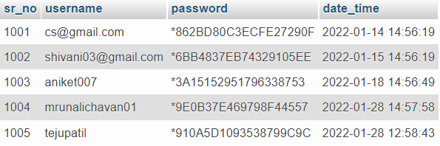

**Report of Orders:**

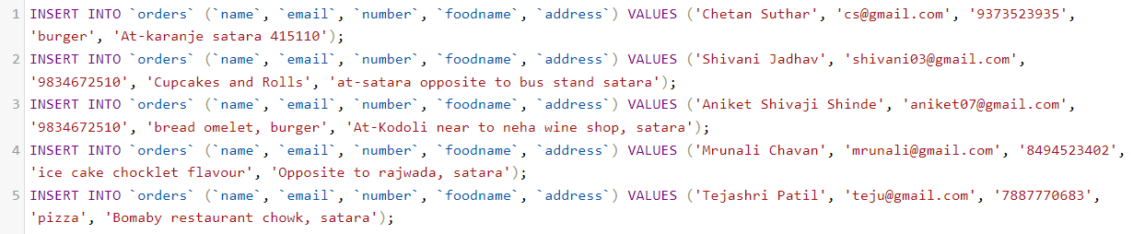

|  |
| --- |
| **Report of Orders:** |

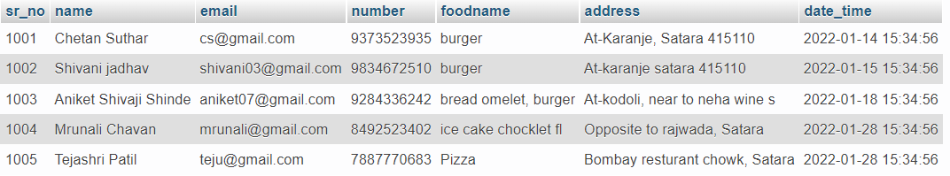

**Report of feedback:**

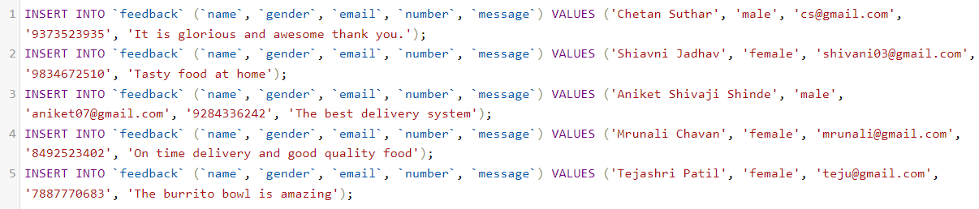

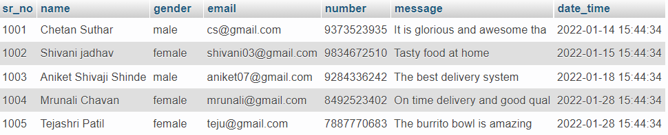

|  |
| --- |
| **Report of feedback:** |

**Chapter 5**

**Problem statement**

**Advantages**

**Disadvantages**

**PROBLEM STATEMENT**

They have huge number of customers daily. So, because large number of customers, they need the help of some features so they can maintain and stores the records accurately. For managers is difficult to view the tables, orders, kitchen, reception and the counter simultaneously.

They need full-fledged website to maintain their day-to-day transactions, orders and also regular update on records, cash transaction, daily staffs report, customers feedbacks etc. In the existing system, entering all the details are done manually, it is taking lots of time and also there are chances for mistakes.

**ADVANTAGES**

* Makes managing orders simple
* Manage entire business at one platform
* Improves productivity
* Keep track of the orders and deliveries
* Complete analysis of your business
* Increase sales and revenue
* Daily and monthly revenue reports

**DISADVANTAGE**

* Data security.
* Risk of losing customers data.
* Chances of a technical problem in the website.
* Sometime mismatch data of orders, customers and drivers.

**Chapter 6**

**Conclusion and limitations**

A Conclusion

B Limitations

C Future scope

**CONCLUSION**

Food ordering system, restaurant menu online can be set-up and customers can easily place order. Also, with a food menu online, tracking the order is done easily, it maintains customer's database and improve food delivery service.

Overall, we have created website in focus of future food ordering system, this website will helpful to many people. Implemented some modules for users’ feedback, we also provide post query if user not receive proper food.

**LIMITATIONS**

* Require internet connectivity if user is ordering.
* Require an any devices like PC, Laptop, Android.

**FUTURE SCOPE**

* Easy use of customer
* Computerized Entry of Details.
* User Friendly Interaction between User and website.
* Easy access to any stage.
* Security Provided.
* Lot of time is getting saved.
* Easy backup of data.
* Easy access for exotic & authentic food.

**Chapter 7**

**Reference:**

1. **Books:**
2. **Web:**

**Books:**

**1 HTML black book**

Author-Steven holtzner

**2 Database system concepts**

Author-Sudarshan

**Web:**

<https://www.javatpoint.com/>

<https://www.w3schools.com/>

https://www.swiggy.com/

https://www.zomato.com/